Explanatory note

Faculty Business and Management

Students:

Avagyan Sergei 141

Muradkhodzhaev Dil’myrad 141

Khamrin Pavel 141

1)Name of the project – “VKSixDegreesOfSeparation”

Annotation of the program – to find and count how many handshakes are between two selected users of the social network (vk.com). Also this program checks six degrees of separation. If the number of handshakes are more than 6, the theory is failed and program ends.

2)Central repository address - <https://github.com/Muradkhujaev/VKSixDegreesOfSeparation>

3)Roles:

Avagyan Sergei – interface of the application

Muradkhodzhaev Dil’myrad – application logic

Khamrin Pavel – testing and application logic

4) Application classes:

1.VKUser (forms the object “user”);

2.VKUserViewData (contains addition information of the user);

3.VKFriendsQueue (fills the list of friends);

4.VKFetcher (connects to the server(vk.com));

5.VKConnectionFinder (finds the path between two selected users);

6.UserInfoFetcher (fetchs the information about the user and read it);

7.Program (runs the application);

8.FriendsFetcher (gets the list of friends);

9.MainForm;

10.ResultForm

5) Application interface

Main Window with textboxes for two users.

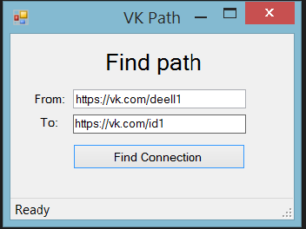

Result Window with the path from start user to the selected one.

